**Practical 5**

|  |  |
| --- | --- |
| Roll No. A016 | Name: Varun Khadayate |
| Program: B-Tech (CSBS) | Division: SY |
| Batch: 1 | Date of Experiment: 13-02-2021 |
| Date of Submission: 27-02-2021 | Grade: |

Aim

To study and implement Object Diagram on the following topics:

1. Relationship Between Person, Student and Employee
2. Customer Order and Payment

Diagram

## Relationship Between person, Student and Employee

### Class Diagram:

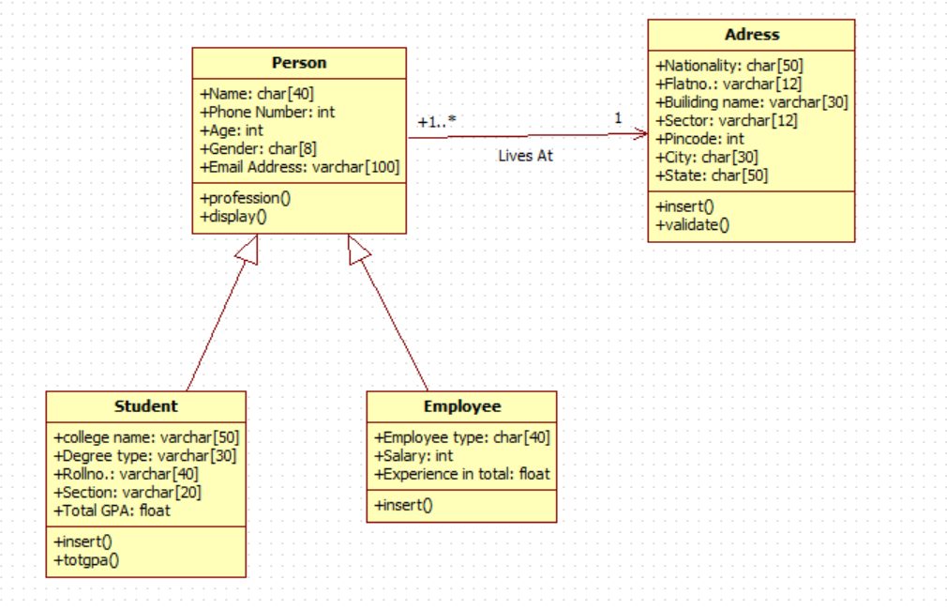

### Object Diagram

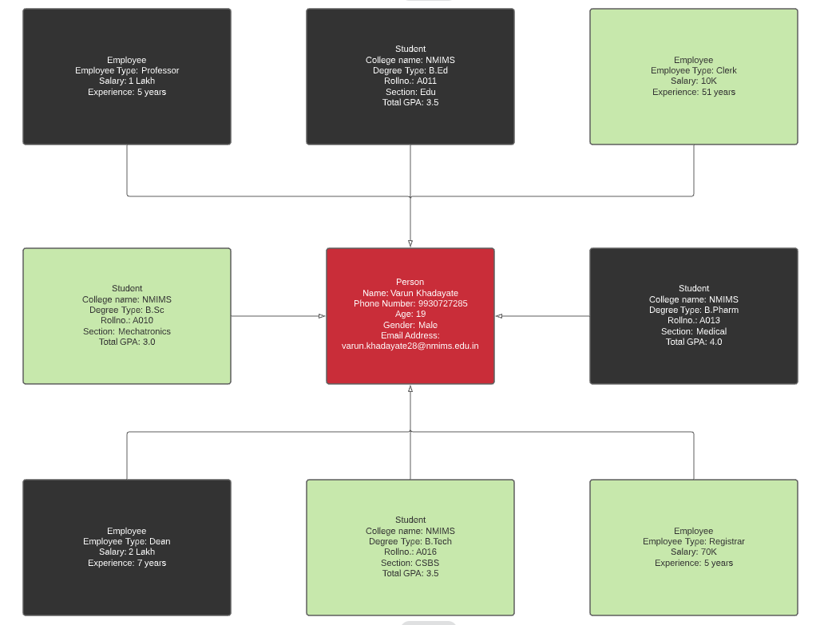

## Customer Order and Payment

### Class Diagram:

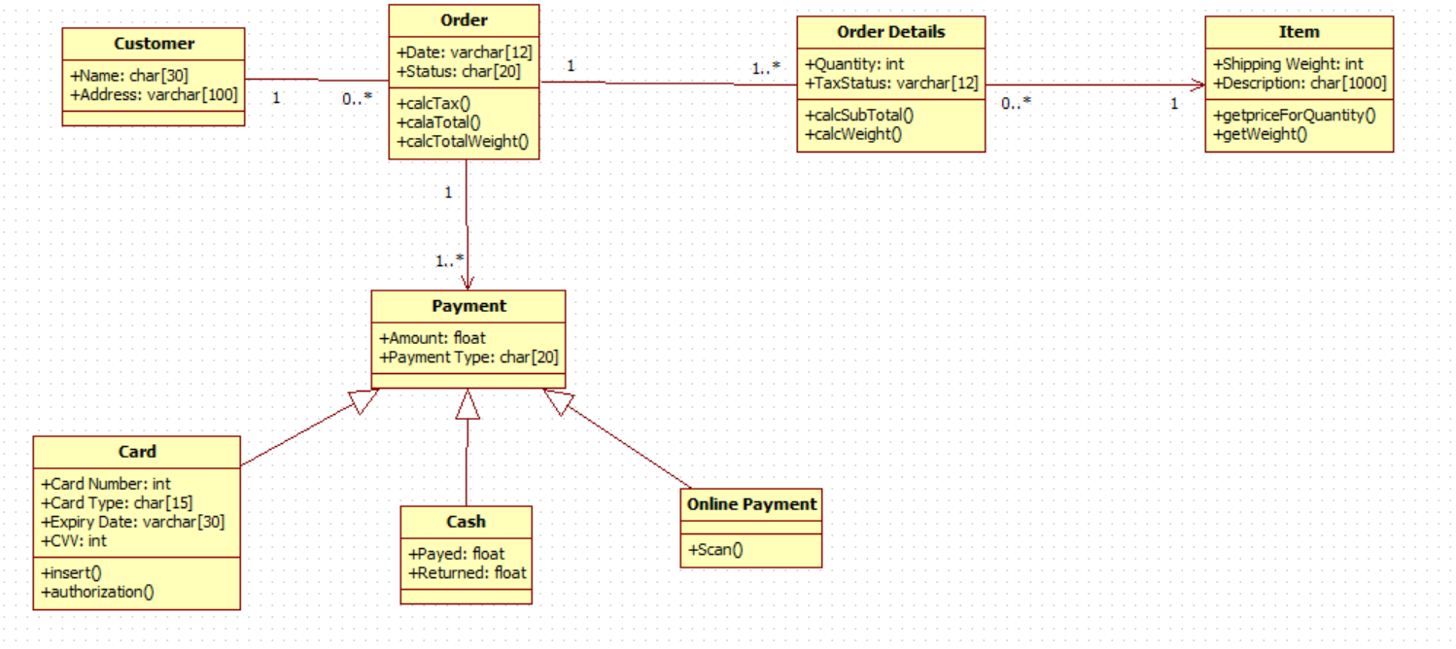

### Object Diagram